

***INTRODUCTION***



***PROJECTSCHEDULE***

System Engineering

Requirement Analysis

Design

Coding

Testing



***REQUIREMENTSANALYSIS***



***DESIGN***

# Analysis Modeling

**System Design Calls:**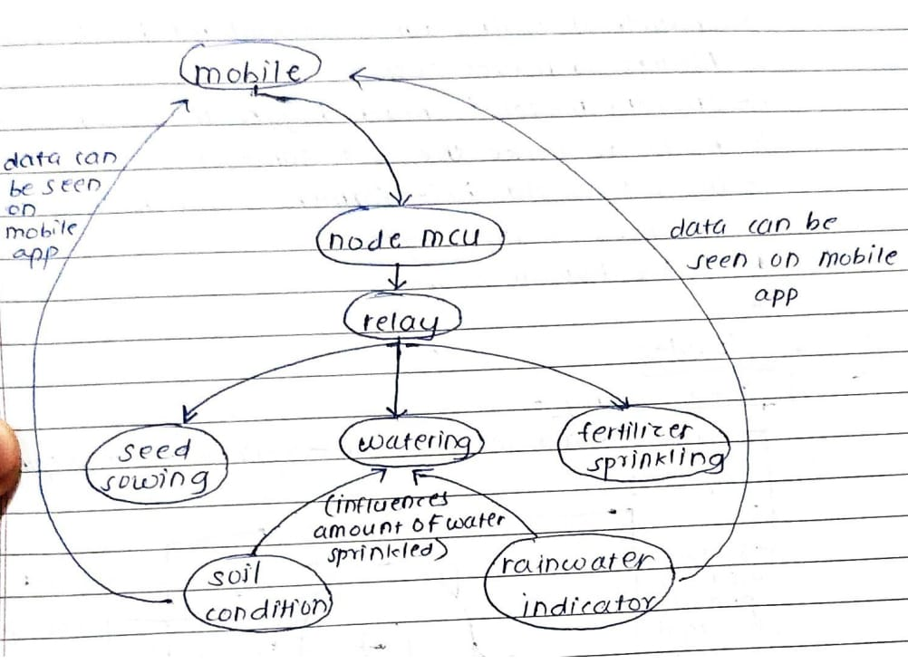

**Fig1.1**

**Characteristics of Embedded systems:**

1. **Embedded Systems :**

Embedded systems are computer systems that perform specific functions within a larger system. They have many characteristics, including:

Real-time operation: Embedded systems must react to changes in their environment and compute results in real time without delay. For example, a car cruise controller monitors and reacts to speed and brake sensors.

Reactivity: Embedded systems must be reactive to their environment. For example, a pilot controlling an aircraft is a reactive real-time system.

Time specific: Embedded systems must operate within a specific time frame.

Low cost: Embedded systems are typically designed to be cost-effective.

Compact size: Embedded systems are designed to be small in size and weight.

Energy efficient: Embedded systems are energy efficient.

Application-specific: Embedded systems are designed for one specific task.

Modular design: Embedded systems have a modular design.

Easy connectivity: Embedded systems have ease of connectivity.



***IMPLEMENTATION***

**`**



***TESTING REPORT***



***PERFORMANCEANALYSIS***



***INSTALLATION GUIDE***



***USERMANUAL***

# USER MANUAL

Step1:Run the bot

Step2:Insert the sensors into the soil

Step3:Check readings on the app

Step3:Allowthewebcameratocaptureyouremotionsandclickonrecommendsongs

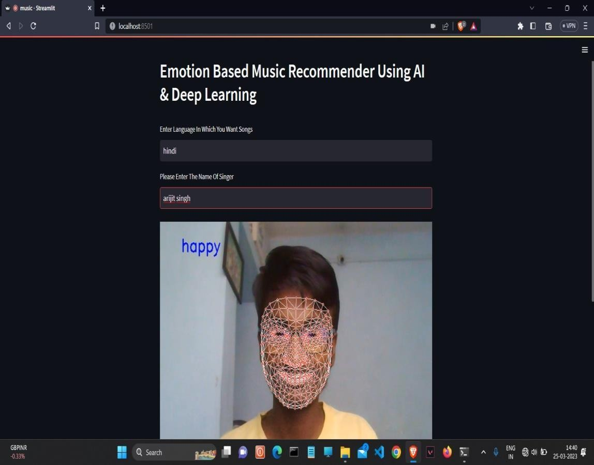

Step 4: Nowyouwill be redirectedtoyoutube anditwill recommendsongsbased on your real time emotions captured





***RESULT***

– **Capturing Soil Condition:**

1. Soil Moiture :
2. Soil pH:

– **Capturing Rain Condition:**

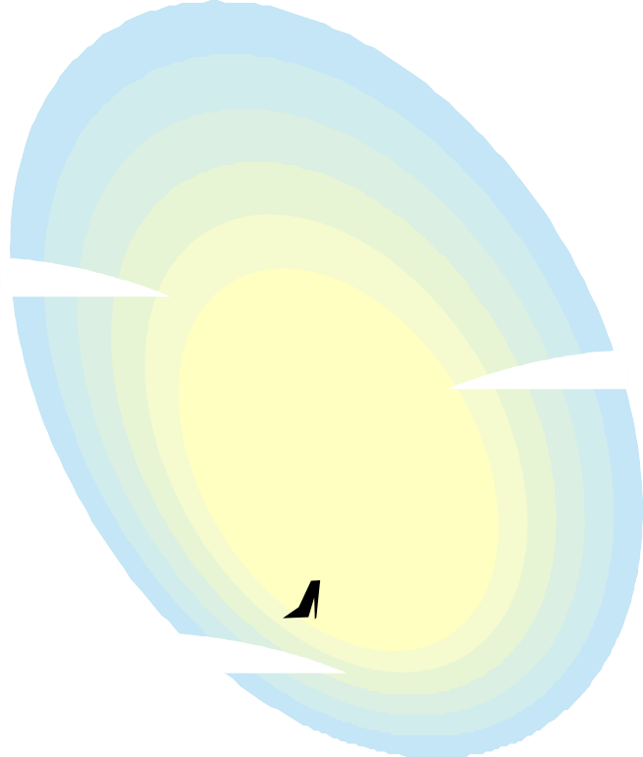

***APPLICATION***



***BIBLIOGRAPHY***